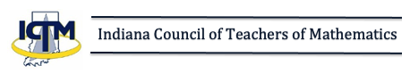
FOR IMMEDIATE RELEASE
The Indiana Council of Teachers of Mathematics (ICTM) joins [NAME OF SCHOOL] in recognizing the efforts of the following student recipients of the 2021 Outstanding Achievement Award for Excellence in Mathematics.
[NAMES OF STUDENTS]
The future looks bright with students like these leading the way!

